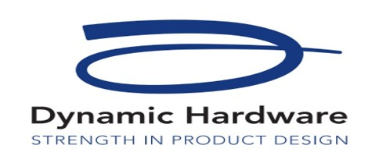

Dynamic Hardware Products Guarantees
Dynamic Hardware guarantee to replace all products free of charge should mechanical failure occur during normal use for a period of ten years from date of purchase. This guarantee does not cover abuse, vandalism, negligence, poor maintenance, or incorrect installation
The product must be supplied by Dynamic Hardware or an approved supplier along with proof of purchase.
1. Where a product is no longer available an alternative product will be offered.
2. No claim can be validated until Dynamic Hardware can inspect the products.
3. Any claim must be made with the seller who the product was originally purchased.
4. Any claims made which ultimately prove false or not Dynamic Hardware’s liability may be charged.
5. Guarantee is invalid if any repairs, modifications, neglect, or cleaning with abrasive / corrosive substances are evident.
6. Dynamic Hardware will not be liable for economic or consequential losses for breach of this guarantee or for selection of incorrect hardware for a given application.
7. Surface finish guarantees, painted and plated products meet BSI Grade 5 - 480 hours neutral salt spray corrosion resistance. Use of abrasive or corrosive substances invalidate any surface finish guarantee.
8. Products should be maintained with light oil for moving parts and cleaned only with warm soapy water every four months.
Dynamic Hardware 20 Year Surface Finish Guarantee.
Dynamic Hardware stainless steel products are supplied with a twenty-year surface finish guarantee.
1. Use of abrasive or corrosive substances will invalidate this guarantee (*see product cleaning and maintenance information sheet).
2. The Dynamic Hardware ten-year mechanical guarantee also applies.

